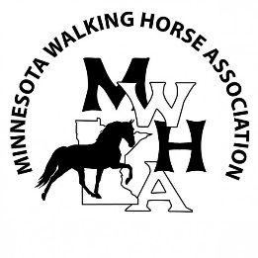
2024 MWHA Programs Application

The MWHA offers four distinct programs with year-end awards in which our members can participate. Complete this registration form and return it with your membership application and your membership dues in order to participate. Hours, shows, events will not count until you are a paid member for the current year. Cost is $15 per nomination / division / horse.

MWHA member/horse owner:
Address:
Phone number & email:
Date completed:

Show High Points Program – The cost is $15 per horse. For each horse you are nominating, please include the division (Plantation, Lite Shod, Trail Pleasure, Country Pleasure, or All Day Pleasure):
Horse’s name: Division (see above for choices): Fee ($15)

Novice Show Program – The cost is $15 per horse. Awards are given the year a novice rider “graduates” out of novice eligibility (3 blue ribbons in a rail class):
Horse’s name: Rider Name: Fee ($15)

Trail Riding / Driving Program – The cost is $15 per division and is based on a horse/rider combination. Please include the age division or category for each horse/rider combination you are nominating (12 & Under, 13-17, 18-39, 40-59, 60 & Over, or Driving):
Horse’s name: Rider/Driver Name: Division (see above) Fee ($15)

Iron Butt Program – The cost is $15 and is based on the rider.
Rider’s name: Fee ($15)

Versatility Program – The cost is $15 per horse and is based on a horse/rider combination.
Horse’s name: Rider’s Name: Fee ($15)

TOTAL FEES:

Reminder: You must be a current paid MWHA member in order to count any points, hours, or events. Make check payable to MWHA and send applicable fees, Membership Application and this Program Application to:

Becky Hansen Questions? Contact Becky at:
5347 Evan Rd. (218) 525-2884
Duluth, MN 55804 nesnahag@aol.com

